Rivers of Life

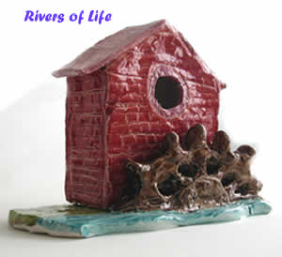
A 2-year project(2005-2007) funded by 'Give it Sum': creative activities inspired by the rivers of the Staffordshire Moorlands producing artwork in textiles, music, painting, photography and creative writing.
We celebrated the culmination of this exciting and rewarding project with a final celebration and exhibition on Monday and Tuesday 9th and 10th October in Leek coinciding with World Mental Health Day. The private view on the evening of the 9th October went extremely well. An invited audience of about 80 or ninety people attended. The exhibition was opened by George Wiskin who until recently was the chairman of the local PCT. There was an extremely interesting talk by Aidan Shingler 'Art and Schizophrenia' together with music from Joe Tatton and Christine Baillot.
The exhibition was open to the public on Tuesday 10th October and was attended by about 300 people, giving us the opportunity to highlight our work. Our target audience were carers, volunteers and the general public and our regular clients gained an opportunity for public recognition of their creative work.

Examples of Artwork Created during the Rivers of Life project
